A Network Virtual Appliance (NVA) in Azure is a virtual machine used to secure, optimize, and route network traffic. It replicates the functions of traditional hardware appliances—such as firewalls, WAN optimizers, and load balancers—allowing you to enforce security policies and manage hybrid connectivity directly in the cloud. [1, 2]
Common Use Cases
- Firewalls & Security: Inspecting inbound and outbound traffic (e.g., next-generation firewalls from providers like Palo Alto, Fortinet, and Check Point).
- Traffic Routing: Managing and steering traffic between virtual networks (VNets), branch offices, and on-premises data centers.
- VPN & SD-WAN: Terminating branch-to-cloud and site-to-site VPN tunnels.
- Load Balancing: Distributing application traffic efficiently across multiple servers. [1, 2, 3, 4, 5]
Deployment Options
NVAs can be deployed in two primary ways in Azure:
- Hub-and-Spoke Topology: NVAs are placed in a centralized "hub" virtual network that acts as a secure gateway inspected by other "spoke" networks.
- Azure Virtual WAN Hub: Integrated directly into Azure’s global software-defined network. You can easily deploy third-party NVAs directly into the Virtual WAN Hub via the Azure Virtual WAN NVA Documentation. [1, 2, 3, 4, 5]
Key Best Practices
- Enable IP Forwarding: For an NVA to route packets correctly between different subnets, you must enable IP forwarding on the NVA's network interfaces.
- Route Tables: You need to explicitly configure Azure Route Tables so that traffic intended for the internet or other networks directs through the NVA.
- High Availability (HA): To avoid single points of failure, deploy NVAs behind an Azure Load Balancer or use built-in NVA clustering and scale sets so traffic automatically fails over. [1, 2, 3]
You can browse and deploy numerous third-party NVAs using the Azure Marketplace. For an in-depth look at implementing and optimizing NVAs, check out the Microsoft Azure NVA Overview.
==========================================================================
https://learn.microsoft.com/en-us/azure/virtual-network/virtual-networks-udr-overview

Lab: Do this
https://learn.microsoft.com/en-us/azure/virtual-network/tutorial-create-route-table?tabs=portal

Tutorial: Route network traffic with a route table
Summarize this article for me
Azure routes traffic between all subnets within a virtual network by default. You can create your own routes to override Azure's default routing. Custom routes are helpful when, for example, you want to route traffic between subnets through a network virtual appliance (NVA).
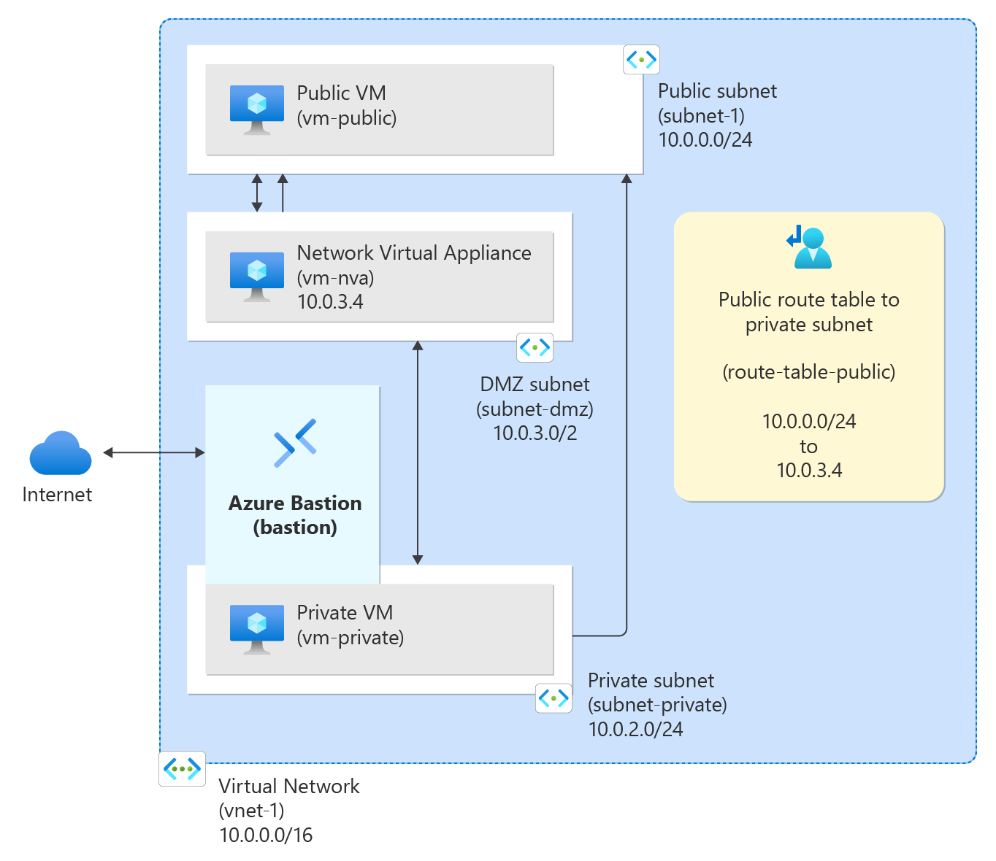
In this tutorial, you learn how to:
- Create a virtual network and subnets
- Create an NVA that routes traffic
- Deploy virtual machines (VMs) into different subnets
- Create a route table
- Create a route
- Associate a route table to a subnet
- Route traffic from one subnet to another through an NVA

Prerequisites
- Portal
- PowerShell
- CLI
- An Azure account with an active subscription. You can create an account for free.

Create subnets
A DMZ and Private subnet are needed for this tutorial. The DMZ subnet is where you deploy the NVA and the Private subnet is where you deploy the private virtual machines you want to route traffic to. In the diagram, subnet-1 is the Public subnet used for the public virtual machine.
- Portal
- PowerShell
- CLI

Create a resource group
- Sign in to the Azure portal.
- In the search box at the top of the portal, enter Resource group. Select Resource groups in the search results.
- Select + Create.
- In the Basics tab of Create a resource group, enter or select the following information:
Setting | Value
Subscription | Select your subscription.
Resource group | Enter test-rg.
Region | Select East US 2.
- Select Review + create.
- Select Create.

Create a virtual network
- In the search box at the top of the portal, enter Virtual network. Select Virtual networks in the search results.
- Select + Create.
- On the Basics tab of Create virtual network, enter or select the following information:
Setting | Value
Project details
Subscription | Select your subscription.
Resource group | Select test-rg.
Instance details
Name | Enter vnet-1.
Region | Select East US 2.
- Select Next to proceed to the Security tab.
- Select Next to proceed to the IP Addresses tab.
- In the address space box in Subnets, select the default subnet.
- In Edit subnet, enter or select the following information:
Setting | Value
Subnet details
Subnet template | Leave the default Default.
Name | Enter subnet-1.
Starting address | Leave the default of 10.0.0.0.
Subnet size | Leave the default of /24 (256 addresses).
- Select Save.
- Select + Add a subnet.
- In Add a subnet, enter or select the following information:
Setting | Value
Subnet details
Subnet template | Leave the default Default.
Name | Enter subnet-private.
Starting address | Enter 10.0.2.0.
Subnet size | Leave the default of /24 (256 addresses).
- Select Add.
- Select + Add a subnet.
- In Add a subnet, enter or select the following information:
Setting | Value
Subnet details
Subnet template | Leave the default Default.
Name | Enter subnet-dmz.
Starting address | Enter 10.0.3.0.
Subnet size | Leave the default of /24 (256 addresses).
- Select Add.
Create one more subnet for Bastion as well as shown below:
- Select + Add a subnet.
- In Add a subnet, enter or select the following information:
Setting | Value
Subnet details
Subnet purpose | Enter Azure Bastion.
Name | Enter AzureBastionSubnet.
Starting address | Enter 10.0.1.0.
Subnet size | Leave the default of /26 (64 addresses).
- Select Add.

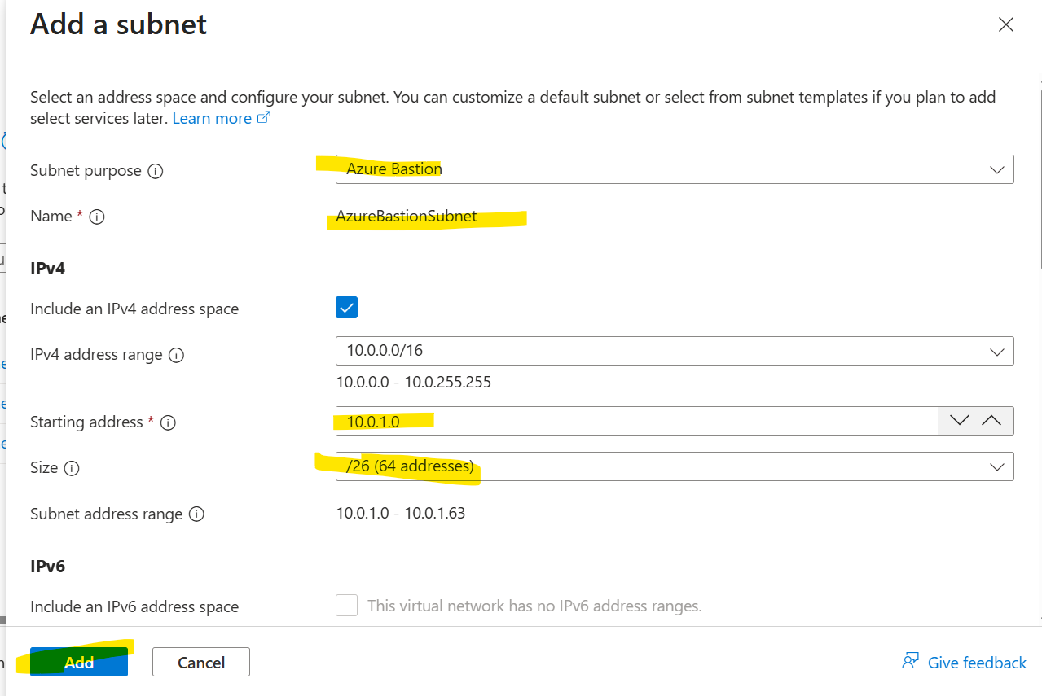
Select Review + create at the bottom of the screen, and when validation passes, select Create.

Deploy Azure Bastion
Azure Bastion uses your browser to connect to VMs in your virtual network over secure shell (SSH) or remote desktop protocol (RDP) by using their private IP addresses. The VMs don't need public IP addresses, client software, or special configuration. For more information about Azure Bastion, see Azure Bastion.
Note
Hourly pricing starts from the moment that Bastion is deployed, regardless of outbound data usage. For more information, see Pricing and SKUs. If you're deploying Bastion as part of a tutorial or test, we recommend that you delete this resource after you finish using it.
- In the search box at the top of the portal, enter Bastion. Select Bastions in the search results.
- Select + Create.
- In the Basics tab of Create a Bastion, enter or select the following information:
Setting | Value
Project details
Subscription | Select your subscription.
Resource group | Select test-rg.
Instance details
Name | Enter bastion.
Region | Select East US 2.
Tier | Select Developer.
Configure virtual networks
Virtual network | Select vnet-1.
Subnet | The AzureBastionSubnet is created automatically/showed in the dropdown with an address space of /26 or larger.
- Select Review + create.
- Select Create.

Create an NVA virtual machine
Network virtual appliances (NVAs) are virtual machines that help with network functions, such as routing and firewall optimization. In this section, create an NVA using an Ubuntu 24.04 virtual machine.
- Portal
- PowerShell
- CLI
- In the search box at the top of the portal, enter Virtual machine. Select Virtual machines in the search results.
- Select + Create then Azure virtual machine.
- In Create a virtual machine enter or select the following information in the Basics tab:
Setting | Value
Project details
Subscription | Select your subscription.
Resource group | Select test-rg.
Instance details
Virtual machine name | Enter vm-nva.
Region | Select (US) East US 2.
Availability options | Select No infrastructure redundancy required.
Security type | Select Standard.
Image | Select Ubuntu Server 24.04 LTS - x64 Gen2.
VM architecture | Leave the default of x64.
Size | Select a size.
Administrator account
Authentication type | Select SSH public key.
Username | Enter a username.
SSH public key source | Select Generate new key pair.
Key pair name | Enter vm-nva-key.
Inbound port rules
Public inbound ports | Select None.
- Select Next: Disks then Next: Networking.
- In the Networking tab, enter or select the following information:
Setting | Value
Network interface
Virtual network | Select vnet-1.
Subnet | Select subnet-dmz (10.0.3.0/24).
Public IP | Select None.
NIC network security group | Select Advanced.
Configure network security group | Select Create new.  In Name enter nsg-nva.  Select OK.
- Leave the rest of the options at the defaults and select Review + create.
- Select Create.

Create public and private virtual machines
Create two virtual machines in the vnet-1 virtual network. One virtual machine is in the subnet-1 subnet and the other virtual machine is in the subnet-private subnet. Use the same virtual machine image for both virtual machines.

Create public virtual machine
The public virtual machine is used to simulate a machine in the public internet. The public and private virtual machines are used to test the routing of network traffic through the NVA virtual machine.
- Portal
- PowerShell
- CLI
- In the search box at the top of the portal, enter Virtual machine. Select Virtual machines in the search results.
- Select + Create then Azure virtual machine.
- In Create a virtual machine enter or select the following information in the Basics tab:
Setting | Value
Project details
Subscription | Select your subscription.
Resource group | Select test-rg.
Instance details
Virtual machine name | Enter vm-public.
Region | Select (US) East US 2.
Availability options | Select No infrastructure redundancy required.
Security type | Select Standard.
Image | Select Ubuntu Server 24.04 LTS - x64 Gen2.
VM architecture | Leave the default of x64.
Size | Select a size.
Administrator account
Authentication type | Select SSH public key.
Username | Enter a username.
SSH public key source | Select Generate new key pair.
Key pair name | Enter vm-public-key.
Inbound port rules
Public inbound ports | Select None.
- Select Next: Disks then Next: Networking.
- In the Networking tab, enter or select the following information:
Setting | Value
Network interface
Virtual network | Select vnet-1.
Subnet | Select subnet-1 (10.0.0.0/24).
Public IP | Select None.
NIC network security group | Select None.
- Leave the rest of the options at the defaults and select Review + create.
- Select Create.

Create private virtual machine
- In the search box at the top of the portal, enter Virtual machine. Select Virtual machines in the search results.
- Select + Create then Azure virtual machine.
- In Create a virtual machine enter or select the following information in the Basics tab:
Setting | Value
Project details
Subscription | Select your subscription.
Resource group | Select test-rg.
Instance details
Virtual machine name | Enter vm-private.
Region | Select (US) East US 2.
Availability options | Select No infrastructure redundancy required.
Security type | Select Standard.
Image | Select Ubuntu Server 24.04 LTS - x64 Gen2.
VM architecture | Leave the default of x64.
Size | Select a size.
Administrator account
Authentication type | Select SSH public key.
Username | Enter a username.
SSH public key source | Select Generate new key pair.
Key pair name | Enter vm-private-key.
Inbound port rules
Public inbound ports | Select None.
- Select Next: Disks then Next: Networking.
- In the Networking tab, enter or select the following information:
Setting | Value
Network interface
Virtual network | Select vnet-1.
Subnet | Select subnet-private (10.0.2.0/24).
Public IP | Select None.
NIC network security group | Select None.
- Leave the rest of the options at the defaults and select Review + create.
- Select Create.

Enable IP forwarding
To route traffic through the NVA, turn on IP forwarding in Azure and in the operating system of vm-nva. When IP forwarding is enabled, any traffic received by vm-nva destined for a different IP address isn't dropped and is forwarded to the correct destination.

Enable IP forwarding in Azure
In this section, you turn on IP forwarding for the network interface of the vm-nva virtual machine.
- Portal
- PowerShell
- CLI
- In the search box at the top of the portal, enter Virtual machine. Select Virtual machines in the search results.
- In Virtual machines, select vm-nva.
- In vm-nva, expand Networking then select Network settings.
- Select the name of the interface next to Network Interface:. The name begins with vm-nva and has a random number assigned to the interface. The name of the interface in this example is vm-nva313.
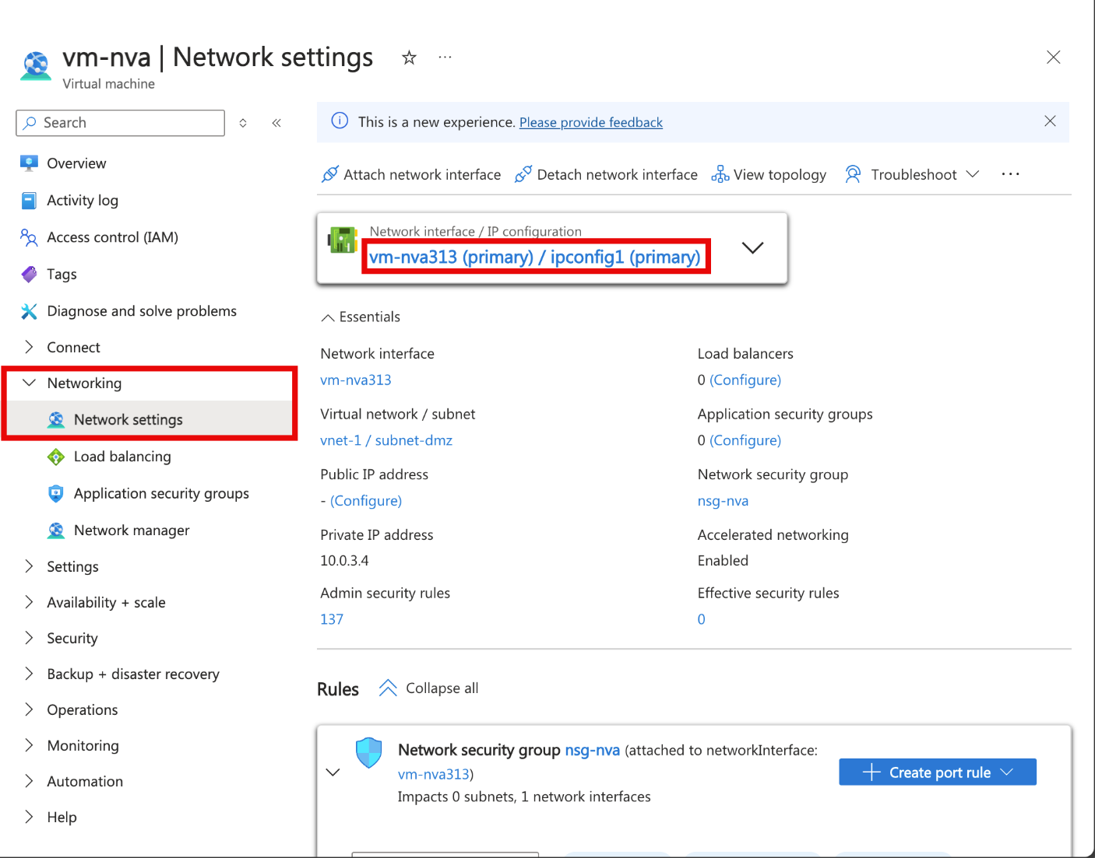
- In the network interface overview page, select IP configurations from the Settings section.
- In IP configurations, select the box next to Enable IP forwarding.
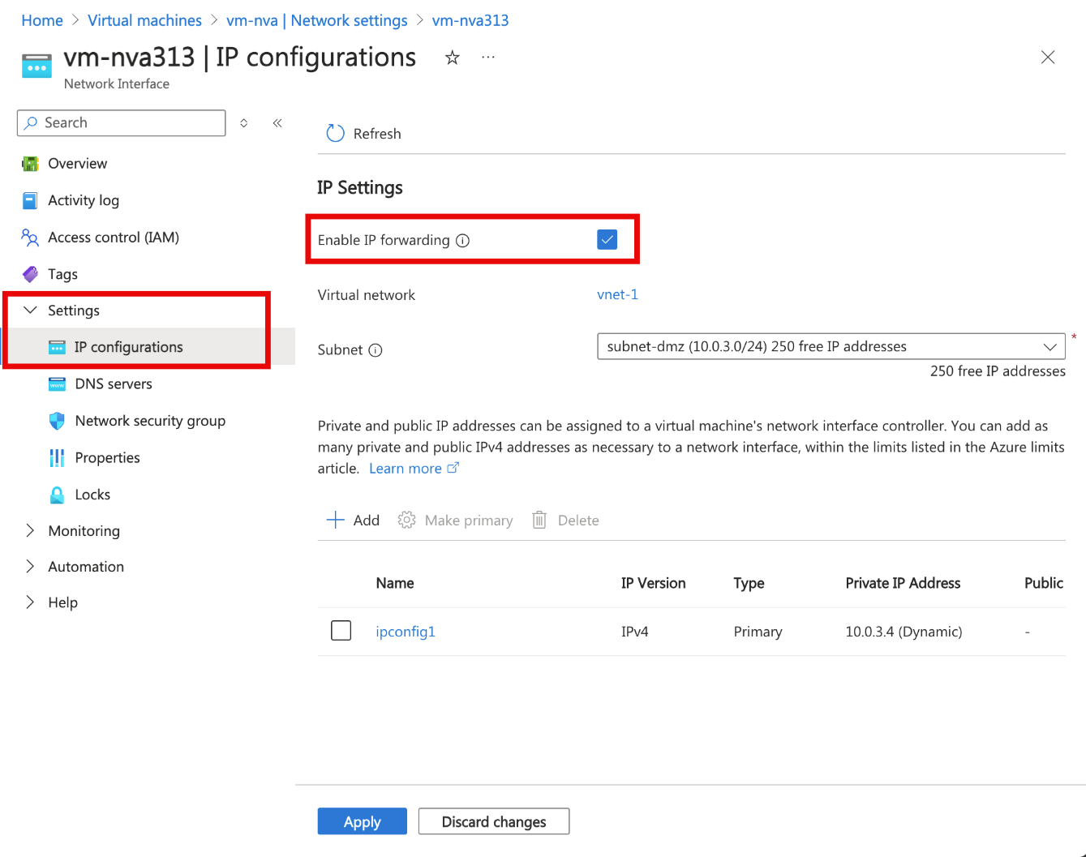
- Select Apply.

Enable IP forwarding in the operating system
In this section, turn on IP forwarding for the operating system of the vm-nva virtual machine to forward network traffic. Use the Run Command feature to execute a script on the virtual machine.
- Portal
- PowerShell
- CLI
- In the search box at the top of the portal, enter Virtual machine. Select Virtual machines in the search results.
- In Virtual machines, select vm-nva.
- Expand Operations then select Run command.
- Select RunShellScript.
- Enter the following script in the Run Command Script window:
Bash
sudo sed -i 's/#net.ipv4.ip_forward=1/net.ipv4.ip_forward=1/' /etc/sysctl.conf
sudo sysctl -p
- Select Run.
- Wait for the script to complete. The output shows the IP forwarding setting has been enabled.
- Return to the Overview page of vm-nva and select Restart to restart the virtual machine.

Create a route table
In this section, create a route table to define the route of the traffic through the NVA virtual machine. The route table is associated to the subnet-1 subnet where the vm-public virtual machine is deployed.
- Portal
- PowerShell
- CLI
- In the search box at the top of the portal, enter Route table. Select Route tables in the search results.
- Select + Create.
- In Create Route table enter or select the following information:
Setting | Value
Project details
Subscription | Select your subscription.
Resource group | Select test-rg.
Instance details
Region | Select East US 2.
Name | Enter route-table-public.
Propagate gateway routes | Leave the default of Yes.
- Select Review + create.
- Select Create.

Create a route
In this section, create a route in the route table that you created in the previous steps.
- In the search box at the top of the portal, enter Route table. Select Route tables in the search results.
- Select route-table-public.
- Expand Settings then select Routes.
- Select + Add in Routes.
- Enter or select the following information in Add route:
Setting | Value
Route name | Enter to-private-subnet.
Destination type | Select IP Addresses.
Destination IP addresses/CIDR ranges | Enter 10.0.2.0/24.
Next hop type | Select Virtual appliance.
Next hop address | Enter 10.0.3.4.  This is the IP address of the vm-nva you created in the earlier steps..
- Select Add.
- Select Subnets in Settings.
- Select + Associate.
- Enter or select the following information in Associate subnet:
Setting | Value
Virtual network | Select vnet-1 (test-rg).
Subnet | Select subnet-1.
- Select OK.

Test the routing of network traffic
Test routing of network traffic from vm-public to vm-private. Test routing of network traffic from vm-private to vm-public.

Test network traffic from vm-public to vm-private
- In the search box at the top of the portal, enter Virtual machine. Select Virtual machines in the search results.
- In Virtual machines, select vm-public.
- Select Connect then Connect via Bastion in the Overview section.
- In the Bastion connection page, enter or select the following information:
Setting | Value
Authentication Type | Select SSH Private Key from Local File.
Username | Enter the username you created.
Local File | Select the vm-public-key private key file you downloaded.
- Select Connect.
- In the prompt, enter the following command to trace the routing of network traffic from vm-public to vm-private:
Bash
tracepath vm-private
The response is similar to the following example:
Output
azureuser@vm-public:~$ tracepath vm-private
1?: [LOCALHOST] pmtu 1500
1: vm-nva.internal.cloudapp.net 1.766ms
1: vm-nva.internal.cloudapp.net 1.259ms
2: vm-private.internal.cloudapp.net 2.202ms reached
Resume: pmtu 1500 hops 2 back 1
You can see that there are two hops in this response for tracepath ICMP traffic from vm-public to vm-private. The first hop is vm-nva. The second hop is the destination vm-private.
Azure sent the traffic from subnet-1 through the NVA and not directly to subnet-private because you previously added the to-private-subnet route to route-table-public and associated it to subnet-1.
- Close the Bastion session.

Test network traffic from vm-private to vm-public
- In the search box at the top of the portal, enter Virtual machine. Select Virtual machines in the search results.
- In Virtual machines, select vm-private.
- Select Connect then Connect via Bastion in the Overview section.
- In the Bastion connection page, enter or select the following information:
Setting | Value
Authentication Type | Select SSH Private Key from Local File.
Username | Enter the username you created.
Local File | Select the vm-private-key private key file you downloaded.
- Select Connect.
- In the prompt, enter the following command to trace the routing of network traffic from vm-private to vm-public:
Bash
tracepath vm-public
The response is similar to the following example:
Output
azureuser@vm-private:~$ tracepath vm-public
1?: [LOCALHOST] pmtu 1500
1: vm-public.internal.cloudapp.net 2.584ms reached
1: vm-public.internal.cloudapp.net 2.147ms reached
Resume: pmtu 1500 hops 1 back 2
You can see there's one hop in this response, which is the destination vm-public.
Azure sent the traffic directly from subnet-private to subnet-1. By default, Azure routes traffic directly between subnets.
- Close the Bastion session.
- Portal
- PowerShell
- CLI
When you finish using the resources that you created, you can delete the resource group and all its resources.
- In the Azure portal, search for and select Resource groups.
- On the Resource groups page, select the test-rg resource group.
- On the test-rg page, select Delete resource group.
- Enter test-rg in Enter resource group name to confirm deletion, and then select Delete.

Next steps
In this tutorial, you:
- Created a route table and associated it to a subnet.
- Created a simple NVA that routed traffic from a public subnet to a private subnet.
You can deploy different preconfigured NVAs from the Azure Marketplace, which provide many useful network functions.
To learn more about routing, see Routing overview and Manage a route table. Routing can also be automatically configured at scale with Azure Virtual Network Manager's user-defined route (UDR) management feature.

==========================================================================

Traffic Routing in Microsoft Azure: Subnet to Network Virtual Appliance (NVA)

When we create a new virtual network (VNet) on Azure, it will route traffic between all subnets within that VNet, by default, thanks to System Routes that it creates and assigns to the route table for each of these subnets within the virtual network. In fact, there are additional optional default and System Routes that are automatically added to route tables, depending on the different capabilities that we enable on the virtual network. For example, routes for VNet peerings, routes to virtual network gateways, BGP routes propagated from an on-premises gateway, routes allowing outbound traffic to flow to the internet from a virtual machine, or routes to service endpoints.
The route tables define routes based on Source, Address prefixes, and Next hop type. The “Next hop type” represents how Azure routes traffic destined for the address prefix listed. The next hop types can be Virtual network, Internet, or None (traffic is dropped). Azure automatically creates the following default system routes for each subnet within the virtual network:
Press enter or click to view image in full size
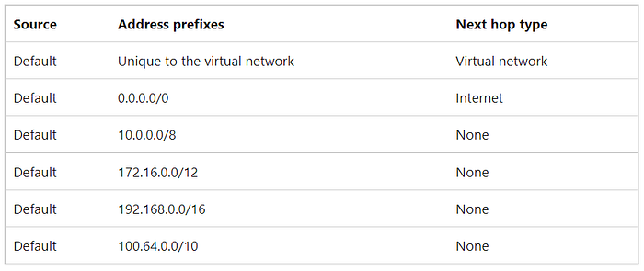
Default System Routes created by Azure
While System Routes cannot be modified or deleted, we have the ability to override them by creating custom static routes. We refer to these as User-Defined Routes (UDRs). UDRs are useful for instances where we need to modify traffic routing behavior so that traffic is sent to an alternate destination.
Use case for creating User-Defined Routes:
Here are some example use cases for creating UDRs:
- To route traffic between subnets through a Network Virtual Appliance
- To force all internet-bound traffic back to on-premises for inspection (forced tunneling)
- To specify next hop behavior in a traffic flow, like Spoke-to-Spoke communication in a Hub-and-Spoke topology, for example.
This lab demonstrates how User-Defined Routes can be created to route traffic between subnets through a network virtual appliance (NVA). In this scenario, any outbound traffic flow from the Public subnet will be redirected to the NVA before being allowed to communicate with the Private subnet. The following steps were executed to accomplish this task:
1. Created a virtual network
2. Created and configured an NVA virtual machine
3. Created a route table
4. Created a route
5. Associated a route table to a subnet
6. Created public and private virtual machines
7. Tested the routing of network traffic
Press enter or click to view image in full size
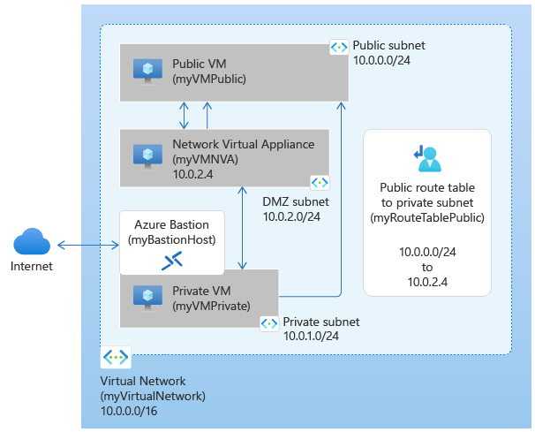
1. Create Virtual Network and Subnets
In Step 1, I created a virtual network with an address space of 10.0.0.0/16 and three subnets:
- Public-Subnet (10.0.0.0/24)
- Private-Subnet (10.0.1.0/24)
- DMZ-Subnet (10.0.2.0/24)
Press enter or click to view image in full size
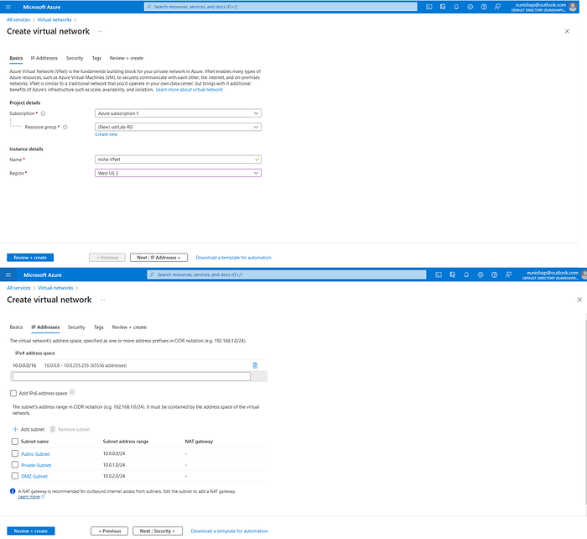
Configuration of Virtual Network and Subnets
A dedicated subnet, AzureBastionSubnet, was created when I deployed an Azure BastionHost. The Azure Bastion is a managed service that provides us with secure access to our Azure networks and devices without needing to create and use a public IP address. I will utilize the Bastion to connect to the Azure environment for testing this demonstration.
Press enter or click to view image in full size
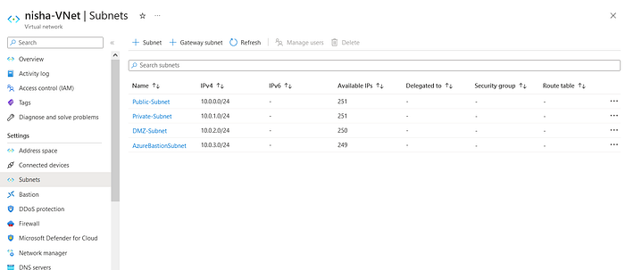
Virtual Network with all subnets configured
2. Created a Network Virtual Appliance (NVA) that routes traffic
A virtual appliance is a virtual machine that typically runs a network application, such as a firewall. To learn about various pre-configured network virtual appliances you can deploy in a virtual network, see the Azure Marketplace.
When you create a route with the virtual appliance hop type, you also specify a next hop IP address. In this step, I deployed a virtual machine into the DMZ subnet of the virtual network. This VM will serve as the Network Virtual Appliance to help with the network traffic routing function that I want to achieve.
Press enter or click to view image in full size
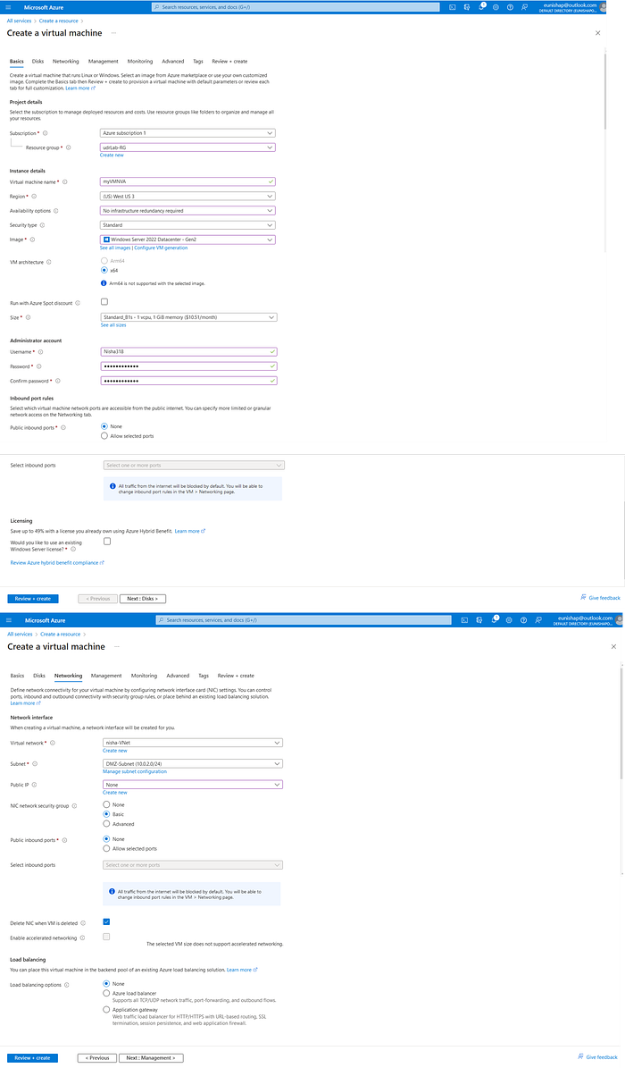
Deployed Network Virtual Appliance into the DMZ Subnet
The NVA has a private IP address of 10.0.2.4
Press enter or click to view image in full size
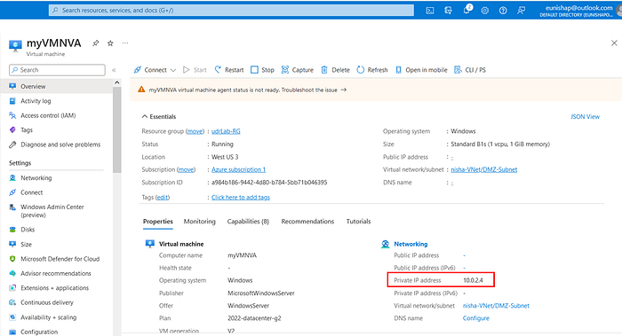
IP address of myVMNVA
Turn on IP Forwarding
To route traffic through the NVA, turn on IP forwarding in Azure and in the operating system of myVMNVA virtual machine. Once IP forwarding is enabled, any traffic received by myVMNVA VM that’s destined for a different IP address, won’t be dropped and will be forwarded to the correct destination.
Turn on IP forwarding in Azure
Press enter or click to view image in full size
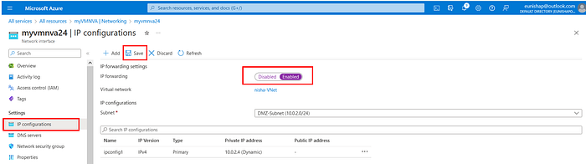
Enable IP Forwarding on myVMNVA
Turn on IP forwarding in the operating system of the NVA

Use the BastionHost to connect to myVMNVA, and then execute the PowerShell command listed below to enable IP forwarding in the Windows Operating System
Set-ItemProperty -PathHKLM:\SYSTEM\CurrentControlSet\Services\Tcpip\Parameters -NameIpEnableRouter -Value1
Press enter or click to view image in full size
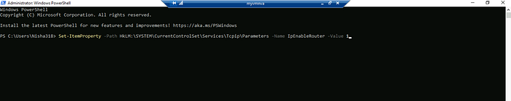
Then, Restart the myVMNVA virtual machine by executing the PowerShell command listed below.
Restart-Computer
Press enter or click to view image in full size
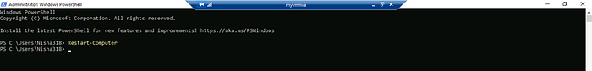
3. Create a route table
Routes are paths through which traffic can flow and these routes are referenced in Azure when determining the next hop for routing traffic through the network. In this step, I created a route table, named myRouteTablePublic, that will be used to hold the routes that I configure for the subnets of the virtual network in the next step.
Press enter or click to view image in full size
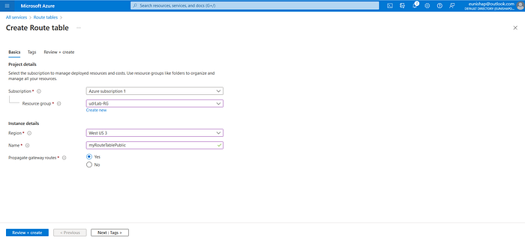
Creation of a Route Table
4. Create a route
Next, I created a route and added it to the route table. Here, I created a route named “ToPrivateSubnet”. This route gives the instructions that any traffic that is destined to the private subnet (10.0.1.0/24) will be redirected such that it will instead have a Next hop type of “Virtual appliance”, which has a Next hop IP address of 10.0.2.4. This is the IP address that is assigned to the NVA.
Press enter or click to view image in full size
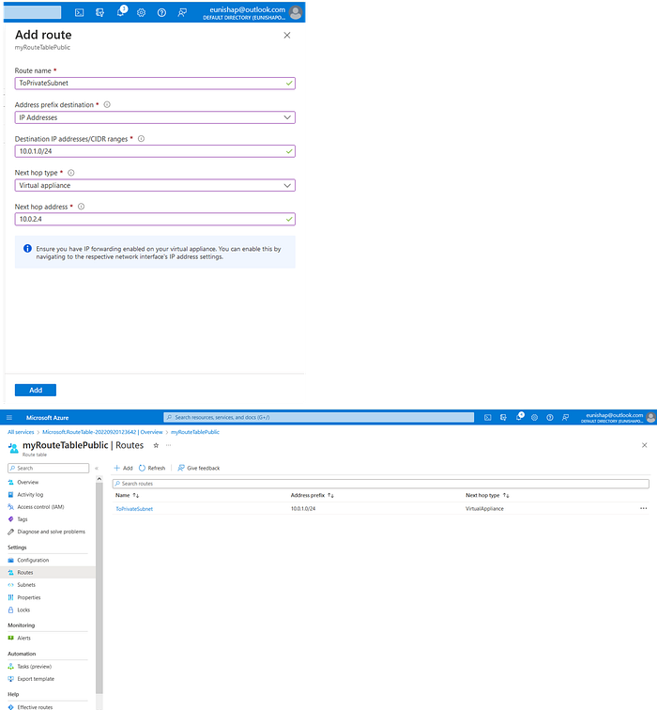
Creation of a custom route
5. Associate a route table to a subnet
Next, we associate the new route table with a subnet so that the subnet will have the new instructions for routing outbound traffic that is destined for the private subnet. The route that has been defined in this route table will override the default System Route that would have otherwise allowed the Public-Subnet to communicate with the Private-Subnet automatically.
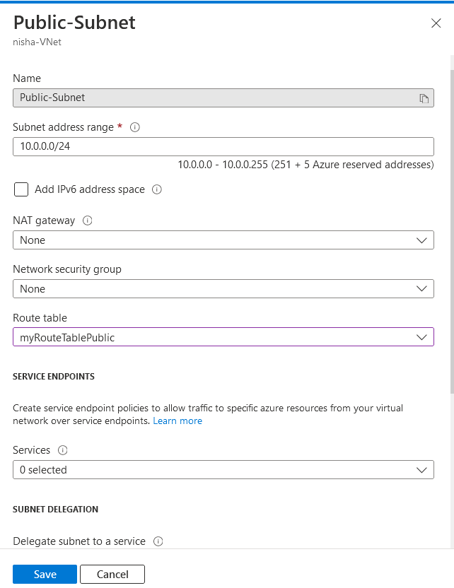
Linking the route table to the subnet
6. Deploy virtual machines (VMs) into different subnets
Next, I deployed virtual machines into the two other subnets, Private-Subnet and Public-Subnet.
Press enter or click to view image in full size
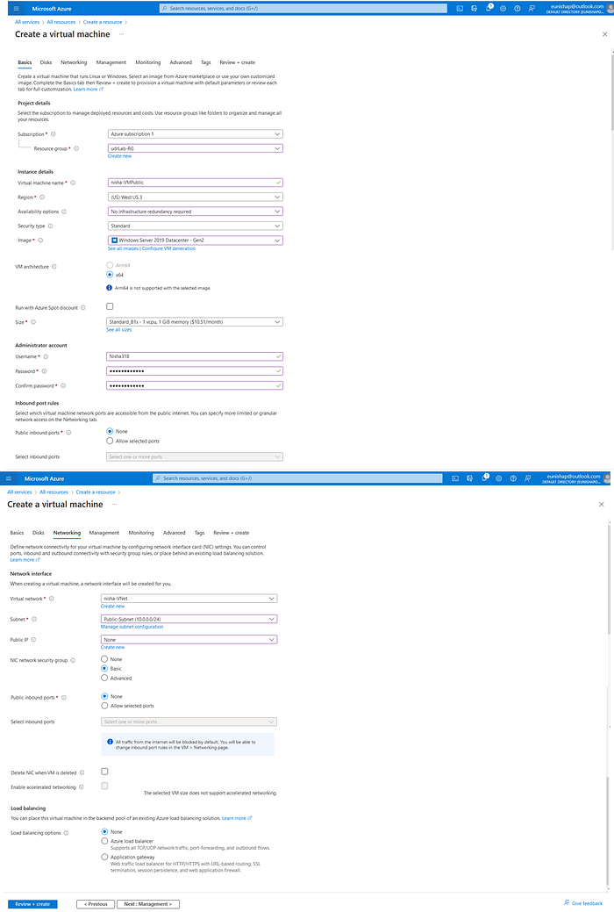
Deployment of virtual machine into the Public-Subnet
Press enter or click to view image in full size
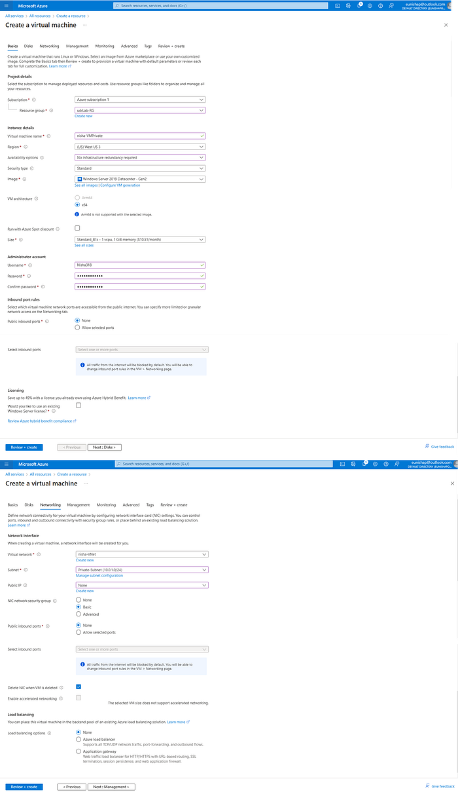
Deployment of virtual machine into the private subnet
Allow ICMP in Windows firewall on Public and Private VMs
Because these are Windows devices, they will block inbound ICMP Echo packets, by default. We will need this enabled so that we can trace routing during the testing of this solution in our next step. The TRACERT diagnostic utility determines the route to a destination by sending Internet Control Message Protocol (ICMP) echo packets to the destination.Here, we have the option to add an inbound firewall rule to allow ICMP (from the Firewall GUI interface, from PowerShell, or we can disable the Windows firewall temporarily to allow ICMP.
Press enter or click to view image in full size
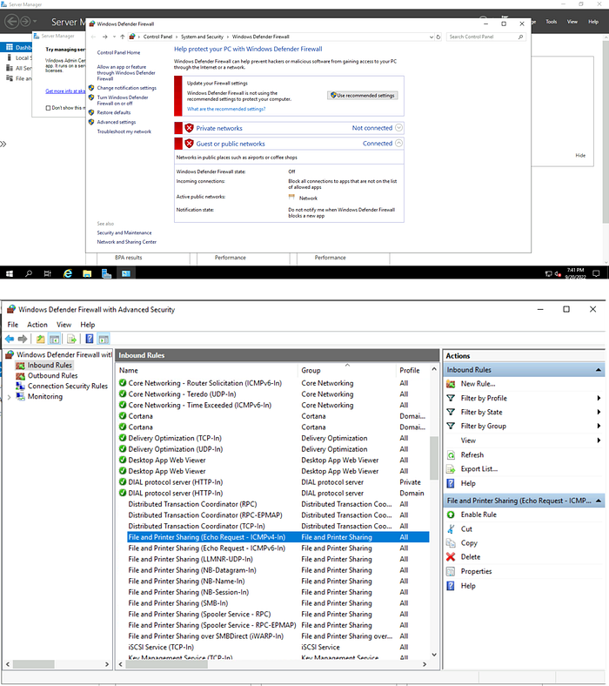
Windows Defender FIrewall Inbound Rules
Press enter or click to view image in full size
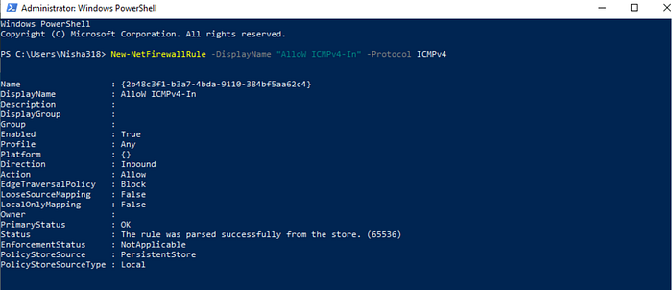
Add New Firewall Rule to allow Inbound ICMP
7. Test the routing of network traffic between the Public and Private VMs
Here, I connected to myVMPublic VM, and used PowerShell to execute the tracert command to trace the routing of network traffic from myVMPublic VM to myVMPrivate VM. We see that there are two hops needed in order for traffic to reach the Private VM from the Public VM. The first hop is that of the NVA device with IP address 10.0.2.4. The second hop finally gets us to the private VM at IP address 10.0.1.4.
tracert nisha-vmprivate
Press enter or click to view image in full size
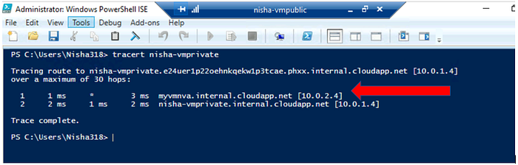
TraceRoute to private VM is initiated
In the reverse direction, there is only one hop for traffic from the Private VM to reach the Public VM. This is expected because we did not apply the custom route to the Private-Subnet. Therefore, the default System Routes are still in play for all outbound traffic leaving the Private-Subnet, which allows traffic routing between all subnets in the virtual network, by default.
Press enter or click to view image in full size
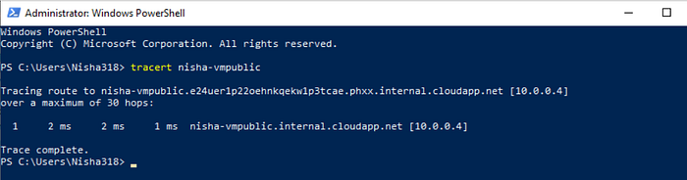
This concludes the traffic routing lab demonstration. I hope that this information has been helpful. Please see the links below for more information about NVAs and creating custom routes.

